Xiang Jerry He
Week 6 & 7
STAT442T – Data Mining
Neural Net and MARS
Introduction:
In previous weeks, we have shown that heuristic methods such as random forest or boosting can significantly outperform logit glm in categorization problems such as detecting breast cancer. We find that the strength of both random forest depends upon many weak predictors having little to none correlation with each other. This week we will investigate a somewhat different problem of regression, where the response variable is quantitative rather than categorical. We will compare the new methods of neural net and MARS against those methods that we already know.
The data sets mars.train.txt and mars.test.txt both have 66 input variables and one response variable. Most of the input variables were quantitative variables from 0 to 1. Their symmetric distributions in terms of range and 1st and 3rd quartiles suggest that they were computer generated. There were also several categorical variables, though they later turned out to have no predictive power.
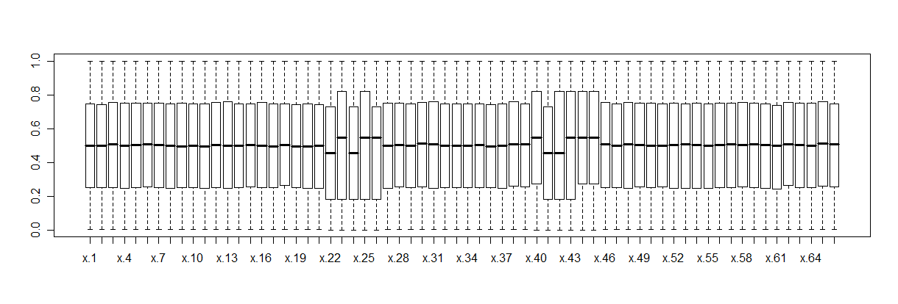
The response is also a quantitative variable
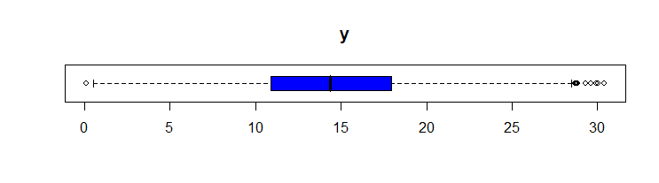
The correlations amongst certain relevant variables are the following:
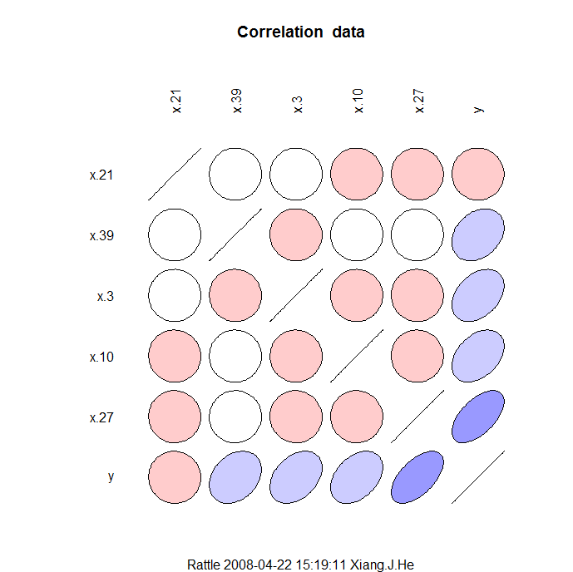

Methods:
The new methods introduced for this period includes Neural Net and MARS (Multivariate Adaptive Regression Splines), both of which we will briefly describe.
Neural Net is an extension of the classical perceptron learner. In fact, it extends the capability of the perceptron by having multiple layers.
Multivariate Adaptive Regression Splines (MARS) is a creation of Jerome Friedman. MARS excels in detecting important variables from others, using an orthogonal basis of Splines.
In addition to these new methods, we try old techniques of random forest and linear regressions. I have also explored (PCA) principle component analysis and k-means clustering. The former turned out to be quite useless as PCA only works best when there are meaningful correlations between many variables. It has turned out that most of the variables have zero predictive power, so PCA turns out to be a very ineffective technique. Hence, only k-means clustering will be discussed in this report. The algorithm to generate a k-means cluster is as follows:
- choose k random centers
- assign points to the nearest center
- compute mean coordinates of all points in each cluster
- repeat until no point switches cluster allegiance.
Using k-means clustering in combination with other methods have been found to be an effective technique. Synergy in combination is achieved by fitting a different instance of the same model on each of the clusters.

Goodness of Fit:
Correlation coefficient is a great measure of goodness of fit; however, correlation coefficient is not very robust to outliers, and sometimes the correlation coefficient may prefer a complex model that overfits an influential point over a simpler, perhaps more correct model.
In week 6, we also explored least squares residual and absolute residual as measures of goodness of fit. We have found that absolute residual works better most of the time, as least squares overweigh the outliers.

Results:
From week 6, most of the results were derived from running models on all variables, most of which were not very promising. Using trees, we had learned that x.27, x.10, x.3 are important; however, trees, or recursive partitioning seems to have missed x.21 and x.39 as important predictors. MARS, on the other hand, was able to determine all the influential variables. We learned that the important variables are simply x.3, x.10, x.21, x.27, x.39; all other variables except x.33 have an importance score of 0; however, we also observe that the importance of x.33 is also magnitudes below that of the first 5, so it could reasonably be dropped from the model. Since MARS is an extension of recursive partitioning, perhaps this is not at all surprising. In fact, MARS can be considered a continuous version of trees.
We should note why random forest does not work so well here. As we had mentioned last week, random forest tries to decouple one predictor from another, which is definitely possible since most variables are pair-wise uncorrelated. However, most variables did not have predictive power, and random forest does not possess a mechanism to realize this.
During week 7, we had run various models using only the important predictors. Our overall results were as follows:
Salford system’s MARS performs best in terms finding variable importance, but in addition to that, it does not perform better than GLM in terms of predictive power. Both methods yielded 95.57% percent accuracy.
JMP offers a very nice interaction graphs which allows us to determine which variables were independent of others. We were able to determine that x.27 and x.39 were independent of any interaction terms. While the quickness of GLM stepping may have rendered this unnecessary for this particular dataset, we will use JMP’s contribution later when we try to develop a test for soundness of model.
Amongst randomized methods, neural net seems to have outperformed Random Forest in terms of both performance and speed. Amongst the nondeterministic techniques, Neural Net performs quite well; on some tries reaching 0.9526 R squared values. This dwarfs most random Forest runs, which averages around 0.9227 R squared.
Our eventual equation turns out to be
Y = -0.8 + 19.9 x.3 + 19.7 x.10 + -20.2 x.21 +

Analysis:
Occam’s razor is a philosophical wisdom widely accepted in the scientific community. According to Occam’s razor we should prefer a simpler model over a more complex one give that both has the same explanatory power. Statistically speaking “same” can be a very subjective term, but in the case of polynomial models, how can we be sure that no other statistical model exists?
One possible approach is to fix all other variables each at some constant (ceteris paribus) and graph y in terms of just one variable. This approach, however, is rather naïve since one can only approximate ceteris paribus by choosing a very narrow window for each of the other variables, so to get informative graphs one would need enormous-sized data. If instead we widen our window, then we end up seeing level curves overlapped together, sometimes in grotesque ways.
A better approach came to me when I thought about Taylor expansion approximations. Given that the relationship is a closed function, and give if the function is analytic, then it must have a Taylor expansion. With the Taylor expansions of most functions, the coefficients of higher order terms tend to decrease very quickly. So statistically speaking, if the range and the distribution of each input does not differ much between the training data and the testing data (1), then we have very little to worry in dropping out higher terms. For example, given a relationship y = x^2 + 0.000001*x^3 for x in [0, 2], the x^3 term nearly does not matter as long as in the testing set x remains in [0, 2], since we know that when x reaches 1000 or so the x^3 will become dominant.
So far I have just reaffirmed our faith in polynomial approximations given (1). We have found a polynomial model
y ~ x.3+x.10+x.21+x.27+x.39+x.3.2+x.10.2+x.21.2+x.3.2:x.10.2+x.3:x.10+x.10:x.10.2+x.3:x.3.2+x.10:x.21+x.3:x.10.2+x.10:x.3.2+x.3:x.27+x.10:x.39,

To prove that higher order terms are insignificant within

Call:
lm(formula = y ~ ., data = data[x.3 < 0.3, ])

Residuals:
Min 1Q Median 3Q Max
-4.6651 -0.7930 0.0163 0.7938 4.5442

Coefficients:
Estimate Std. Error t value Pr(>|t|)
(Intercept) 2.86718 0.12426 23.074 <2e-16 ***
x.3 15.40820 1.00885 15.273 <2e-16 ***
x.10 4.92837 0.30379 16.223 <2e-16 ***
x.21 -20.39197 0.30378 -67.127 <2e-16 ***
x.27 9.92663 0.07514 132.101 <2e-16 ***
x.39 4.98151 0.07675 64.908 <2e-16 ***
x.3.2 -2.40772 3.24446 -0.742 0.458
x.10.2 -0.45224 0.29536 -1.531 0.126
x.21.2 20.31937 0.29453 68.990 <2e-16 ***
---
Signif. codes: 0 ‘***’ 0.001 ‘**’ 0.01 ‘*’ 0.05 ‘.’ 0.1 ‘ ’ 1

Residual standard error: 1.199 on 2998 degrees of freedom
Multiple R-Squared: 0.9182, Adjusted R-squared: 0.918
F-statistic: 4205 on 8 and 2998 DF, p-value: < 2.2e-16

Call:
lm(formula = y ~ ., data = data[x.3 > 0.7, ])

Residuals:
Min 1Q Median 3Q Max
-5.518859 -0.863317 0.000285 0.883319 4.340382

Coefficients:
Estimate Std. Error t value Pr(>|t|)
(Intercept) -2.08940 2.63700 -0.792 0.428223
x.3 18.56958 6.24755 2.972 0.002979 **
x.10 34.64056 0.33516 103.354 < 2e-16 ***
x.21 -19.97811 0.33953 -58.841 < 2e-16 ***
x.27 10.13637 0.08619 117.604 < 2e-16 ***
x.39 5.11612 0.08581 59.619 < 2e-16 ***
x.3.2 -12.74160 3.67288 -3.469 0.000529 ***
x.10.2 -29.67763 0.32475 -91.387 < 2e-16 ***
x.21.2 19.97581 0.32902 60.712 < 2e-16 ***
---
Signif. codes: 0 ‘***’ 0.001 ‘**’ 0.01 ‘*’ 0.05 ‘.’ 0.1 ‘ ’ 1

Residual standard error: 1.358 on 3051 degrees of freedom
Multiple R-Squared: 0.9171, Adjusted R-squared: 0.9168
F-statistic: 4217 on 8 and 3051 DF, p-value: < 2.2e-16

Call:
lm(formula = y ~ ., data = data[x.10 < 0.3, ])

Residuals:
Min 1Q Median 3Q Max
-4.47581 -0.81147 -0.01352 0.80923 4.61636

Coefficients:
Estimate Std. Error t value Pr(>|t|)
(Intercept) 2.78960 0.12565 22.202 <2e-16 ***
x.3 4.91846 0.31327 15.701 <2e-16 ***
x.10 15.53521 1.03758 14.973 <2e-16 ***
x.21 -20.26118 0.31334 -64.663 <2e-16 ***
x.27 9.95578 0.07666 129.864 <2e-16 ***
x.39 5.02261 0.07820 64.229 <2e-16 ***
x.3.2 -0.52546 0.30367 -1.730 0.0837 .
x.10.2 -1.65706 3.36499 -0.492 0.6224
x.21.2 20.16770 0.30144 66.904 <2e-16 ***
---
Signif. codes: 0 ‘***’ 0.001 ‘**’ 0.01 ‘*’ 0.05 ‘.’ 0.1 ‘ ’ 1

Residual standard error: 1.219 on 2985 degrees of freedom
Multiple R-Squared: 0.916, Adjusted R-squared: 0.9158
F-statistic: 4070 on 8 and 2985 DF, p-value: < 2.2e-16

Call:
lm(formula = y ~ ., data = data[x.10 > 0.7, ])

Residuals:
Min 1Q Median 3Q Max
-5.11128 -0.87691 0.02458 0.87653 5.31410

Coefficients:
Estimate Std. Error t value Pr(>|t|)
(Intercept) -2.20163 2.60096 -0.846 0.397359
x.3 35.56134 0.33642 105.704 < 2e-16 ***
x.10 18.78887 6.16573 3.047 0.002329 **
x.21 -19.88793 0.33418 -59.512 < 2e-16 ***
x.27 9.94680 0.08341 119.248 < 2e-16 ***
x.39 5.03594 0.08399 59.958 < 2e-16 ***
x.3.2 -30.65876 0.32391 -94.652 < 2e-16 ***
x.10.2 -12.83583 3.62628 -3.540 0.000407 ***
x.21.2 19.99318 0.32612 61.306 < 2e-16 ***
---
Signif. codes: 0 ‘***’ 0.001 ‘**’ 0.01 ‘*’ 0.05 ‘.’ 0.1 ‘ ’ 1

Residual standard error: 1.327 on 3010 degrees of freedom
Multiple R-Squared: 0.9191, Adjusted R-squared: 0.9189
F-statistic: 4275 on 8 and 3010 DF, p-value: < 2.2e-16

Call:
lm(formula = y ~ ., data = data[x.21 < 0.3, ])

Residuals:
Min 1Q Median 3Q Max
-8.32340 -1.11168 -0.04435 1.08766 8.10197

Coefficients:
Estimate Std. Error t value Pr(>|t|)
(Intercept) -0.6370 0.1726 -3.690 0.000228 ***
x.3 19.9498 0.4290 46.501 < 2e-16 ***
x.10 19.7988 0.4259 46.491 < 2e-16 ***
x.21 -20.2080 1.4224 -14.207 < 2e-16 ***
x.27 9.9053 0.1050 94.354 < 2e-16 ***
x.39 5.0597 0.1069 47.343 < 2e-16 ***
x.3.2 -13.4454 0.4148 -32.417 < 2e-16 ***
x.10.2 -13.1973 0.4107 -32.130 < 2e-16 ***
x.21.2 17.5367 4.5855 3.824 0.000134 ***
---
Signif. codes: 0 ‘***’ 0.001 ‘**’ 0.01 ‘*’ 0.05 ‘.’ 0.1 ‘ ’ 1

Residual standard error: 1.686 on 3057 degrees of freedom
Multiple R-Squared: 0.8837, Adjusted R-squared: 0.8834
F-statistic: 2904 on 8 and 3057 DF, p-value: < 2.2e-16

Call:
lm(formula = y ~ ., data = data[x.21 > 0.7, ])

Residuals:
Min 1Q Median 3Q Max
-7.12253 -1.02509 -0.03918 1.00989 5.76335

Coefficients:
Estimate Std. Error t value Pr(>|t|)
(Intercept) 0.9585 3.1240 0.307 0.759002
x.3 20.3341 0.4249 47.851 < 2e-16 ***
x.10 20.3469 0.4088 49.776 < 2e-16 ***
x.21 -25.5518 7.4050 -3.451 0.000567 ***
x.27 10.0552 0.1029 97.764 < 2e-16 ***
x.39 5.1397 0.1037 49.556 < 2e-16 ***
x.3.2 -13.6595 0.4102 -33.296 < 2e-16 ***
x.10.2 -13.3929 0.3973 -33.711 < 2e-16 ***
x.21.2 23.5115 4.3501 5.405 7e-08 ***
---
Signif. codes: 0 ‘***’ 0.001 ‘**’ 0.01 ‘*’ 0.05 ‘.’ 0.1 ‘ ’ 1

Residual standard error: 1.627 on 2956 degrees of freedom
Multiple R-Squared: 0.8911, Adjusted R-squared: 0.8908
F-statistic: 3023 on 8 and 2956 DF, p-value: < 2.2e-16

Call:
lm(formula = y ~ x.3 + x.10 + x.21 + x.27 + x.39 + x.3.2 + x.10.2 +
x.21.2 + x.3.2:x.10.2 + x.3:x.10 + x.10:x.10.2 + x.3:x.3.2 +
x.3:x.10.2 + x.10:x.3.2, data = data[x.3 > 0.7, ])

Residuals:
Min 1Q Median 3Q Max
-3.39849 -0.67000 -0.00472 0.68873 3.86938

Coefficients:
Estimate Std. Error t value Pr(>|t|)
(Intercept) 27.33759 22.88477 1.195 0.2323
x.3 -73.76582 80.17540 -0.920 0.3576
x.10 -44.48307 26.28352 -1.692 0.0907 .
x.21 -19.86290 0.25127 -79.049 < 2e-16 ***
x.27 10.06876 0.06382 157.766 < 2e-16 ***
x.39 5.06679 0.06353 79.753 < 2e-16 ***
x.3.2 78.70679 93.69716 0.840 0.4010
x.10.2 51.32253 25.26087 2.032 0.0423 *
x.21.2 19.83939 0.24350 81.477 < 2e-16 ***
x.3.2:x.10.2 17.46258 34.98245 0.499 0.6177
x.3:x.10 137.88965 62.14096 2.219 0.0266 *
x.10:x.10.2 -4.83663 0.94584 -5.114 3.36e-07 ***
x.3:x.3.2 -27.49184 36.54131 -0.752 0.4519
x.3:x.10.2 -101.95260 59.56442 -1.712 0.0871 .
x.10:x.3.2 -55.96210 36.47799 -1.534 0.1251
---
Signif. codes: 0 ‘***’ 0.001 ‘**’ 0.01 ‘*’ 0.05 ‘.’ 0.1 ‘ ’ 1

Residual standard error: 1.005 on 3045 degrees of freedom
Multiple R-Squared: 0.9547, Adjusted R-squared: 0.9545
F-statistic: 4583 on 14 and 3045 DF, p-value: < 2.2e-16
Call:
lm(formula = y ~ x.3 + x.10 + x.21 + x.27 + x.39 + x.3.2 + x.10.2 +
x.21.2 + x.3.2:x.10.2 + x.3:x.10 + x.10:x.10.2 + x.3:x.3.2 +
x.3:x.10.2 + x.10:x.3.2, data = data[x.3 < 0.3, ])

Residuals:
Min 1Q Median 3Q Max
-3.755256 -0.663304 -0.005396 0.633797 3.452321

Coefficients:
Estimate Std. Error t value Pr(>|t|)
(Intercept) 4.79241 0.18674 25.663 < 2e-16 ***
x.3 7.30539 3.14265 2.325 0.02016 *
x.10 0.73910 0.92872 0.796 0.42620
x.21 -20.21090 0.25302 -79.879 < 2e-16 ***
x.27 9.90262 0.06262 158.140 < 2e-16 ***
x.39 4.99126 0.06391 78.095 < 2e-16 ***
x.3.2 -38.97763 17.93920 -2.173 0.02988 *
x.10.2 0.27091 1.60375 0.169 0.86587
x.21.2 20.19044 0.24529 82.312 < 2e-16 ***
x.3.2:x.10.2 -111.08571 36.12313 -3.075 0.00212 **
x.3:x.10 7.20560 11.52902 0.625 0.53202
x.10:x.10.2 -0.95437 0.97161 -0.982 0.32605
x.3:x.3.2 53.91640 35.84611 1.504 0.13266
x.3:x.10.2 25.46856 11.16135 2.282 0.02257 *
x.10:x.3.2 91.20681 37.41224 2.438 0.01483 *
---
Signif. codes: 0 ‘***’ 0.001 ‘**’ 0.01 ‘*’ 0.05 ‘.’ 0.1 ‘ ’ 1

Residual standard error: 0.998 on 2992 degrees of freedom
Multiple R-Squared: 0.9435, Adjusted R-squared: 0.9432
F-statistic: 3566 on 14 and 2992 DF, p-value: < 2.2e-16

Conclusions:
MARS is an effective method for testing variable importance, a true improvement upon recursive partitioning (trees). Whereas trees are limited in its ability to select influential variables, MARS pretty much does this perfectly. All non-relevant variables except one have weight 0, and the one mistaken variable have much lower weight than those that matter.
We have concluded, with Occam’s Razor, that the best model is ____ , but the correct model is actually_____.
95.57% is the standard goodness.

